|  |
| --- |
| Ladd Creek-Highway 203 Bridge Replacement Project Proposal |
| Ladd Creek/Ladd Marsh Wildlife Area Channel Relocation and Wetland Restoration Project |
| DSC_0091.JPG  Submitted to the Grande Ronde Model Watershed for consideration by |
| **Winston Morton and Vance McGowan** |
| **Oregon Department of Fish and Wildlife** |
| **9/1/2012** |

|  |
| --- |
|  |

Watershed Enhancement Project Proposal

September 2012

**1. Project Name: Ladd Creek-Highway 203 Bridge Replacement**

**2. Applicant:** Oregon Department of Fish and Wildlife, Grande Ronde Basin Fish Habitat Enhancement Project

**3. Participating Landowner(s) and Agencies:**

Oregon Department of Fish and Wildlife (Landowner)

Oregon Department of Transportation

Confederated Tribes of the Umatilla Indian Reservation

Grande Ronde Model Watershed

Union County/ Federal Aviation Administration

**4. Project Contact(s):**

Project Manager:

Vance McGowan, ODFW

107 20th St La Grande, OR 97850

541.962.1836

[vance.r.mcgowan@state.or.us](mailto:vance.r.mcgowan@state.or.us)

Project Engineer:

Ken Patterson, ODOT

3014 Island Ave La Grande, OR 97850

541.963.1365

[Kenneth.E.PATTERSON@odot.state.or.us](mailto:Kenneth.E.PATTERSON@odot.state.or.us)

Technical Contact:

Allen Childs, CTUIR

Ag Services Center Rm. #4 10507 North McAlister Rd. Island City, OR 97850

541.429.7940

[allenchilds@ctuir.com](mailto:allenchilds@ctuir.com)

Administrative Contact:

Julie Burke, CTUIR DNR Administrative Manager, Fiscal Agent

46411 Timine Way Pendleton, OR 97801

541.429.7292

[julieburke@ctuir.com](mailto:julieburke@ctuir.com)

**5. Project Location:**

The project is located approximately 5.5 miles southeast of La Grande, Oregon on Ladd Creek, a tributary to Catherine Creek, in the Upper Grande Ronde Subbasin. This location is within the boundaries of the Ladd Marsh Wildlife Area (LMWA). The legal description for the project is Township 3 South, Range 39 East, Section 31, Willamette Meridian, Union County, OR. GPS coordinates for the location are the following: Lat: 45.2608, Long: -117.9842. The proposed new bridge would be for Oregon Highway 203 and span Ladd Creek at approximately river mile 4.9. Please see Figure 1 for a detailed map.



**6. Project Objectives:**

The Ladd Creek-Highway 203 Bridge Replacement Project is the final phase of the Ladd Creek/LMWA Channel Restoration and Wetland Enhancement Project (GRMW ID 1766). The overall project objectives are:

* Replace channelized and incised reaches of the various forks of Ladd Creek with natural meandering channels with accessible floodplain habitats.
* Remove undersized culverts that restricted fish passage.
* Increase both quantity and quality of rearing habitat for anadromous and resident salmonids.
* Promote natural, stable stream channels and in-stream habitat diversity.
* Improve water quality (sediment, nutrient exchange, water temperatures, flow).
* Increase groundwater storage and recharge.
* Restore former wetland habitats for riparian and wetland dependent species.

Replacement and relocation of the Ladd Creek-Highway 203 Bridge and connection of the 6,500 feet of new channels built in 2009-2010 are actions that will assist in accomplishing these objectives. The above objectives are consistent with the Grande Ronde Subbasin Plan (2004) Habitat Goals (Section 5.2.1.1):

* Protect high quality habitat, restore degraded habitats, and provide connectivity between functioning habitats.
* Manage for healthy ecosystems to support aquatic resources and native species.

The Grande Ronde Subbasin Plan Supplement (2004) identifies the Catherine Creek watershed as one of the 5 highest priority restoration areas in the Upper Grande Ronde. The document similarly provides a framework for screening and identifying the priority of proposed projects as well as strategies to accomplishing objectives in the Grande Ronde Subbasin, for example:

**Table 3-2: The EDT identified five highest priority Geographic Areas for restoration and key factors limiting survival for each Grande Ronde subbasin steelhead population (page 15).**

Within this table, the Mid-Catherine Creek reach (Ladd Creek is a tributary to Catherine in this reach) is listed as one of the priority areas. Limiting factors with High and Medium Impact are: Habitat Diversity, Key Habitat Quantity, Sediment, and Temperature.

**Table 5-6 - Framework for screening and identifying the priority of proposed projects in the Grande Ronde subbasin (page 46).**

The table includes concepts and strategies, such as:

♦ “***Restore watershed connectivity limiting key fish and wildlife populations”***

***Strategy-*** Restoring fish passage to good habitats by restoring passage at road-crossing barriers

♦ ***"Restore watershed processes impacting the aquatic system, water quality-limited streams, and wildlife habitat" Strategy***- Restoring hydrology to reestablish wetlands in the landscape

♦ ***“Channel Condition” Strategy***- Reconstruct channelized stream reaches to historic or near-historic form and location whereappropriate and feasible; Improve the density, condition and species composition of riparian vegetationthrough planting, seeding; Grazing management and improved forest management practices; Install in channelstructures (LWD, boulders, rock structures) as appropriate to improve habitat complexity in the shortterm.

The project location and objectives are consistent with the GRSP goals and the GRSP Supplement’s restoration location prioritization and strategies for completing desired objectives.

**7. Project Description**

Introduction

Ladd Creek is a tributary to Catherine Creek within the Upper Grande Ronde subbasin and provides habitat for ESA listed Snake River Summer Steelhead and Spring Chinook. The adjacent lands are almost exclusively within the ODFW Ladd Marsh Wildlife Area (LMWA) which support riparian and wetland habitats for a host of fish and wildlife species. Ladd Creek was channelized and ditched in the 1920’s and 1930’s. The stream courses and drainage patterns were severely altered as a result of agricultural practices, road and railroad construction. Streams in the lower gradient valley bottoms were frequently placed along property lines running North/South or East/West, or realigned in road barrow ditches. At road crossings, culverts were often installed instead of bridges, and were frequently undersized. The existing culvert for Highway 203 crossing Ladd Creek is undersized and located in an area unsuitable based on geomorphic conditions and other artificial constraints. It frequently backs water up and can potentially create confusion for out-migrating salmonids.

In 2009-2010 ODFW Grande Ronde Fish Habitat Program implemented the Ladd Creek/LMWA Channel Reconstruction and Wetland Restoration Project (GRMW ID 1766). This project encompasses about 680 acres of stream, riparian and wetland habitats. The overall scope and complexity of this project, along with an extensive planting effort, make it one of the largest stream restoration projects undertaken in Northeast Oregon. The overall goal of this project is to improve passage and summer and winter rearing habitat for ESA listed Snake River Summer Steelhead and Spring/Summer Chinook salmon. Activities completed in 2009-10 included: 1) Construction of 5.4 miles of new channels; 2) Reclamation of 2.02 miles of streams/ditches; 3) Additions of 246 pieces of large wood (>1 ft. diameter) and 147 pieces of small wood; 4) Removal of 2 undersized culverts; 5) Installation of a free-spanning bridge along Pierce Road; 6) Screening of an irrigation diversion; and 7) Planting approximately 52 acres of new riparian areas with 57,602 trees, shrubs and sedge/rush plugs.

The replacement of the Highway 203 culvert is the final phase of this project. GRMW/BPA and other cost-share funds will be used to construct the new bridge and connect the remaining 6,500 feet of previously built stream channels and associated floodplains completing this project.

Existing condition

The Ladd Creek/LMWA Channel Restoration and Wetland Enhancement Project planning and development began in 2005 under OWEB GA No. 206-350. Elements of the project included new channel construction, wetland restoration, plantings, replacement of 3 culverts, large wood additions, and ditch reclamation. Nearly all elements of that project were completed by 2010 (listed above). Part of the original project proposal was to install a new bridge under Highway 203 in the appropriate geomorphic location for the relocated stream channels. Replacement of the existing culvert was also desired after ODFW survey data showed that it only passes a ~25-year flood event (Figure 2).

Currently, at higher flows Ladd Creek backs up water from this culvert (Figure 3) which then flows toward another undersized culvert on Barney Creek to the south. At the present time, the lower 1,280 feet of the East Fork Ladd Creek and 4,362 feet of the main fork of Ladd Creek still flow in channelized stream portions within the Ladd Marsh Wildlife Area, or along roadside ditches adjacent to Highway 203 and is further constrained by the Union Pacific Railroad to the east (Figures 4 and 5). The habitat conditions/complexity within these reaches are poor and are not meeting objectives. The channels and floodplain built in 2009-10 to replace this reach (6500 feet) will greatly increase the amount of available fish and riparian habitat. Salmonid use has been documented in Ladd Creek. Specifically, ODFW documented young of the year Chinook salmon utilizing the lower reaches of Ladd Creek and they have been found as far upstream in the East Fork of Ladd Creek just below Hot Lake Lane.



**Figure 2.** Existing undersized 7.5’ tall x 12’ wide culvert along Highway 203, April 10, 2006. Photo is taken from the downstream side, looking south. Flows were only about 50 cfs (bankfull = 65 cfs), but water surfaces were within 1.2 feet of the top of the culvert.

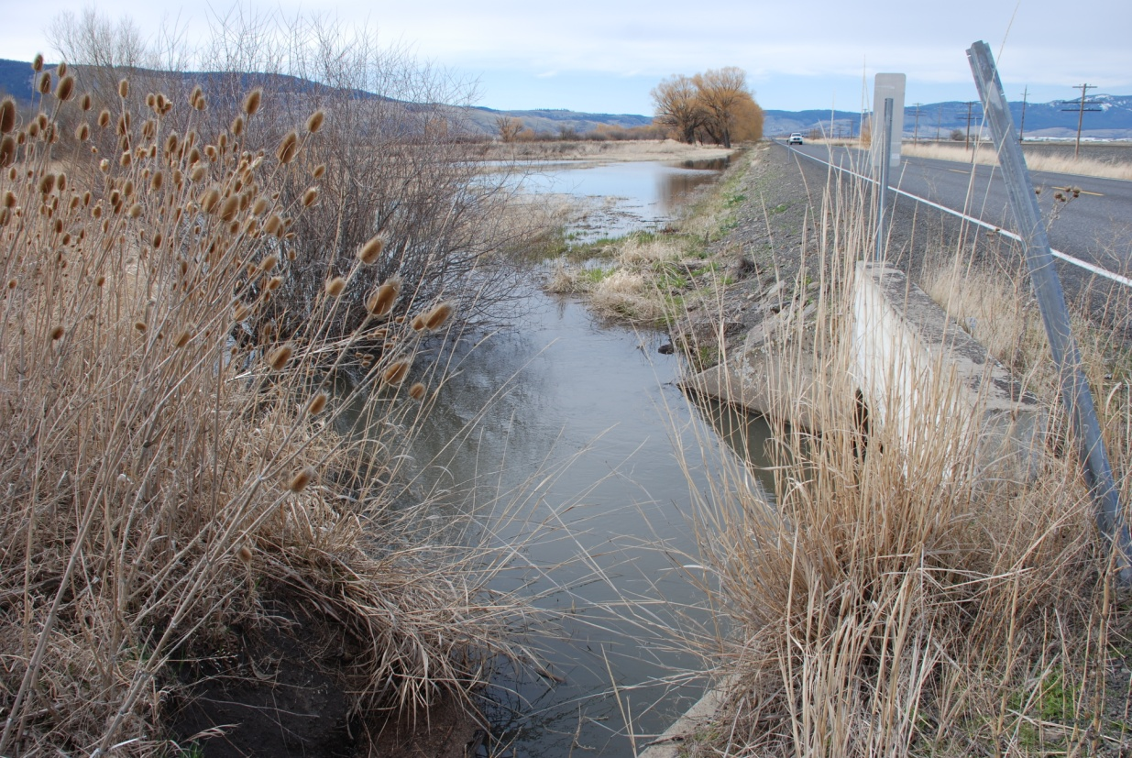

**Figure 3.** Existing Highway 203 culvert, from the southeast side of the culvert, looking northwest, April 2, 2012. Flows are similar to those noted above. Note back watering effects at very moderate flows.

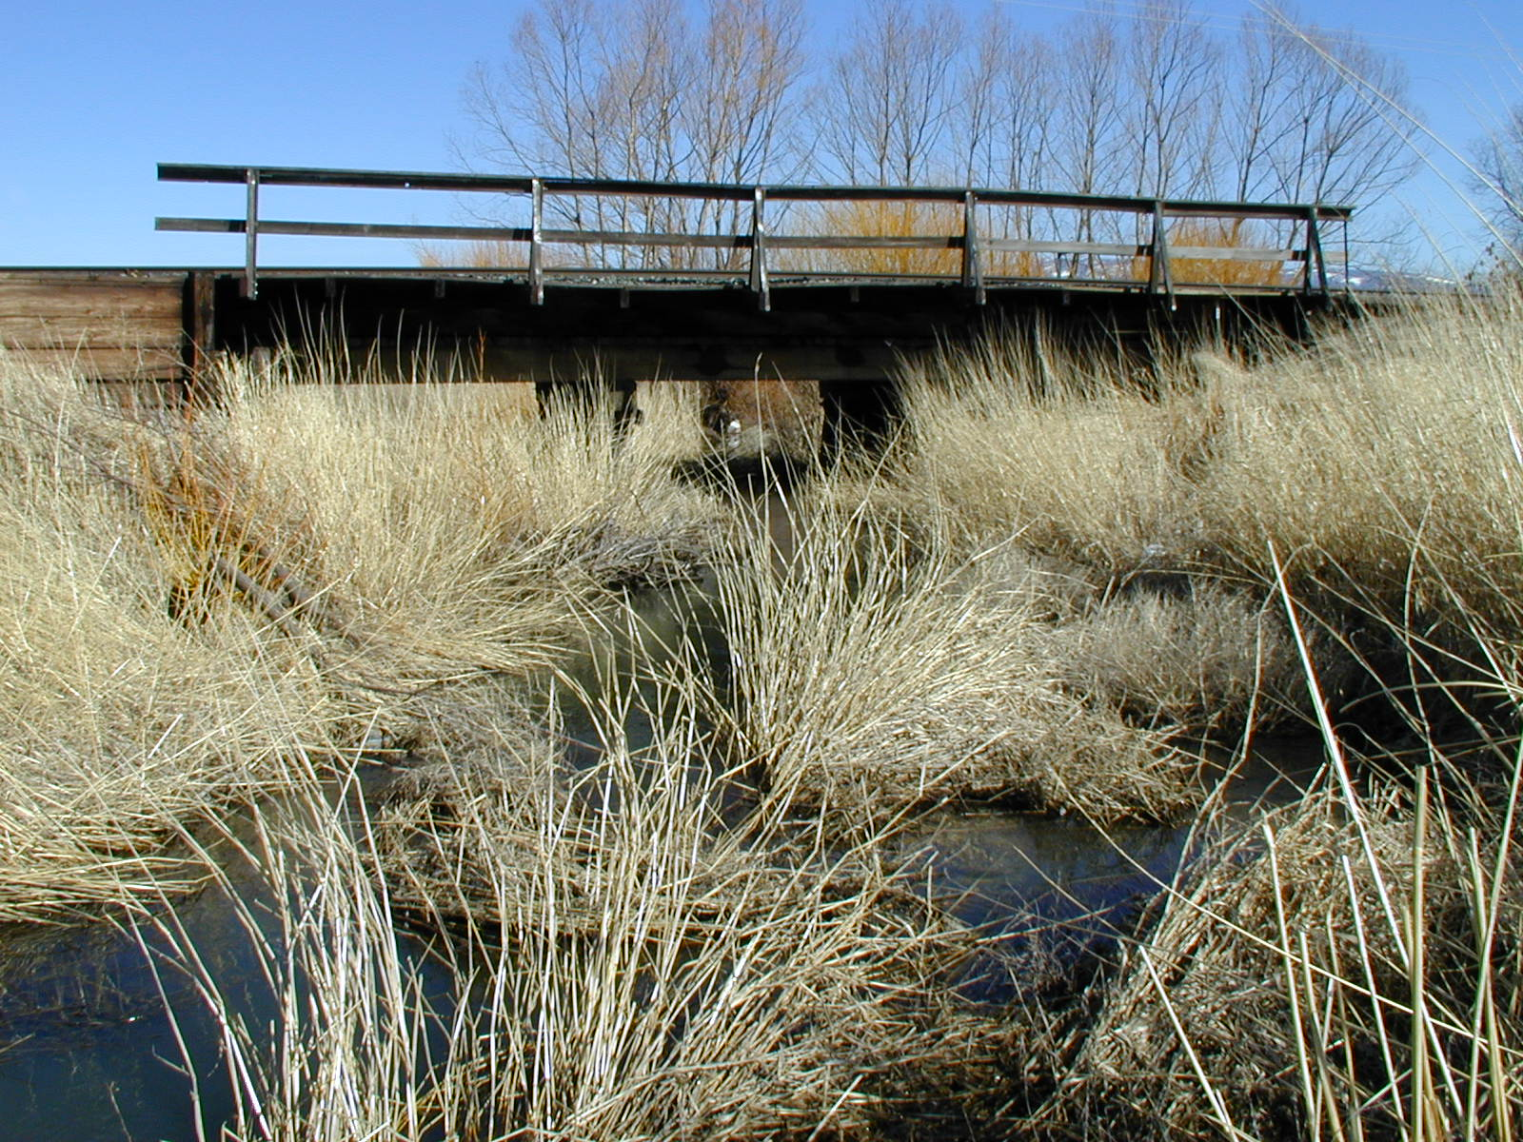

**Figure 4.** Existing Union Pacific railroad bridge over Ladd Creek, 3-14-2008. Photo is taken from the northeast edge of Highway 203 looking northeast and downstream at river mile 4.9.

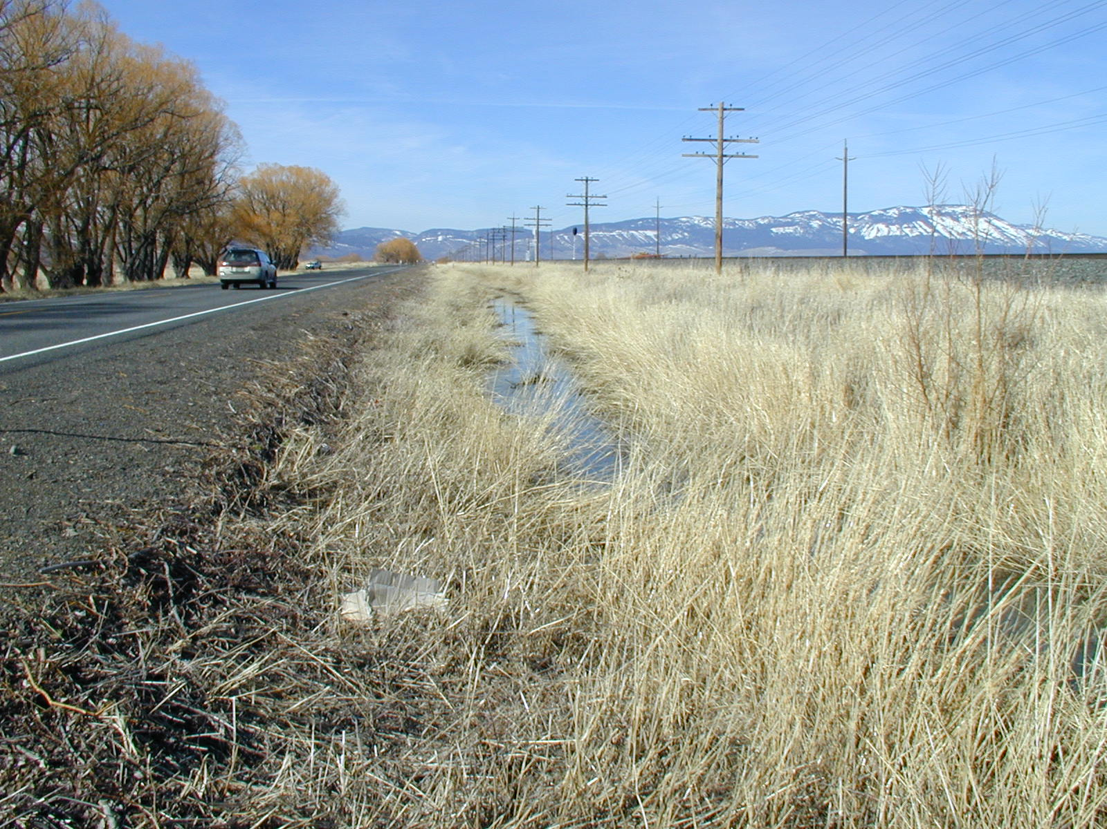

**Figure 5.** Existing Ladd Creek ditch from the same location as Figure 4, looking northwest and upstream, 3-14-2008. The creek is severely constrained on both sides by road or railroad with no high quality habitat in this reach.

Specific Actions

Collectively the following tasks are specifically proposed to meet the project objectives described in Section 6 above.

***Task 1***: Bridge Replacement

Install a new bridge on Oregon Highway 203 over Ladd Creek at RM 4.9 following engineer specifications (see Figures 1, 6 and 7).

* Replace an existing undersized (7’5”x12’x36’) culvert with a new, higher capacity bridge/culvert (7’x24’x36’ or similar).
* Relocate the new structure to a more appropriate geomorphic location.
* The new bridge will be countersunk and have natural channel substrates placed in the bottom; slopes will match surrounding reference sites.

***Task 2***: Connect new channel segments

Divert the East Fork of Ladd Creek and the West+Middle Fork of Ladd Creek at pre-determined locations to activate new channels and direct flows through the new bridge (see Figures 1, 6 and 7).

***Task 3***: Plant Native Vegetation in disturbed areas

Native species associated with riparian and wetland communities will be planted with success criteria of > 50% survival rate.

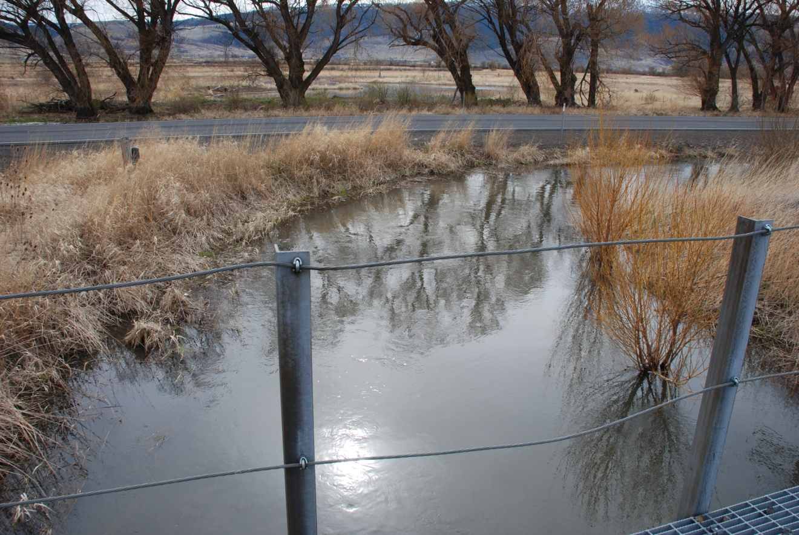

**Figure 6.** Existing Ladd Creek and proposed location of new bridge (arrow), 4-2-2012. Photo is taken from top of the railroad bridge looking southwest toward the highway. Note the standing water on the far side of the highway is where the new channels were built in 2009-10.

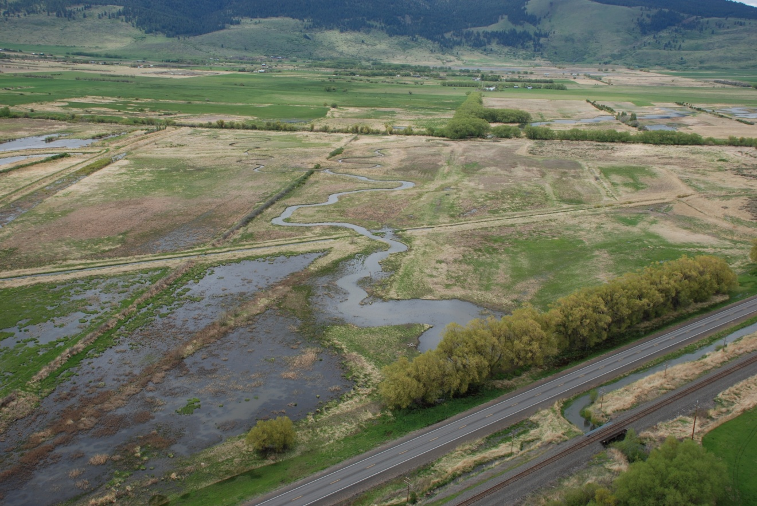

**Figure 7.** Aerial view of the new bridge site (arrow), looking southwest, 5-1-2012. New channels are filled with groundwater but are not yet activated at connection points. The railroad bridge and existing Ladd Creek ditch is in the lower right of the photo.

Benefits

Replacement and relocation of the existing Ladd Creek-Highway 203 culvert will complete the Ladd Creek Channel Relocation and Wetland Restoration Project (GRMW ID 1766). Project benefits of improving passage and summer and winter rearing habitat for ESA listed Snake River Summer Steelhead and Spring/Chinook Salmon are realized upon completion of project objectives. The net effect of realigning the channelized portions into natural meandering stream channels will have resulted in a gain of 10,249 ft. of stream length, and an overall increase in sinuosity from 1.16 to 1.80. The amount of floodplains and wetlands activated by the project are conservatively estimated at 175 acres. Salmonid and non-game native species will benefit from the increase in diversity of channel habitat, installation of LWD, and reestablishment of native riparian vegetation. Potentially, water quality over the long term may improve for salmonids as summer maximum water temperatures decrease as well as daily diurnal temperature fluctuations decreases.

With the project being located in and encompassing 680 acres of LMWA many wildlife species will benefit. Examples include the use of the LMWA by elk, deer and pronghorn antelope as winter range and multitude of both resident and migratory waterfowl and shore birds.

In addition to the benefits for fish and wildlife, the replacement of the undersized and out-dated culvert will allow for better hydraulic connectivity potentially reducing backwater effects as well as suppress the peak flow impacts as activation of floodplains and wetlands act as storage reservoirs. During years of high flows this may decrease the potential flooding effects on infrastructure and surrounding private lands.

Project Maintenance

ODOT-Bridge Maintenance:

Highway 203 is maintained by the Oregon Department of Transportation and they will conduct standard bridge inspection and maintenance.

ODFW-Project maintenance:

ODFW Grande Ronde Fish Habitat will inspect for channel stability, fish passage, and document project results and Status reporting as outlined in annual statements of work to BPA.

Permits

Permitting will be completed by ODFW. The below table contains the permits that will be renewed or applied for Fall/Winter 2012.

|  |  |  |
| --- | --- | --- |
| **Project Activity Requiring a Permit/License** | **Permit or License Name** | **Entity Issuing Permit or License** |
| Bridge Replacement | SLOPES or HIP 2 | USACE or NOAA |
| Connect Channel Segments | Cultural Resources | SHPO# AP-942, case no. 07-0146; |
|  |  | 8/2007 |
|  | Nationwide Permit No. 27 | USACE, NWP-2008-473; 3/27/2009 |
|  |  | (to be renewed) |
|  | Removal/Fill | Oregon Division of State Lands: |
|  |  | 41142-RF, 11/4/2012 (to be renewed) |

Monitoring Plan

ODFW Grande Ronde Fish Habitat will monitor the project in accordance with the Work Elements 157 and 162 within its annual statement of work submitted to BPA (http://www.cbfish.org/Project.mvc/Display/1984-025-00). The milestones associated with these work elements will allow evaluation of project objectives. Pre-project monitoring has been completed and long term monitoring such as photopoints, temperature data collection, solar radiation input data collection, and channel geomorphology data collection will continue for a minimum of ten years. Reporting will be through Pisces and thorough documentation will be included in the program annual report.

Work Dates

The following table is the approximate time line for this project.



**8. Project Budget**

This budget is preliminary and based on previous estimates by ODOT before completion of a 30% design.



1. **Attachments**

Draft Highway 203 Bridge designs for this proposal are either attached to this document or accompany this document electronically as a separate pdf file.